**Sample Dashboard for Wealth Mgmt**

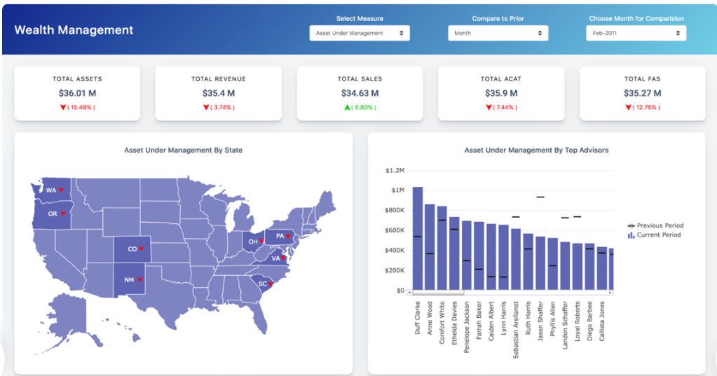

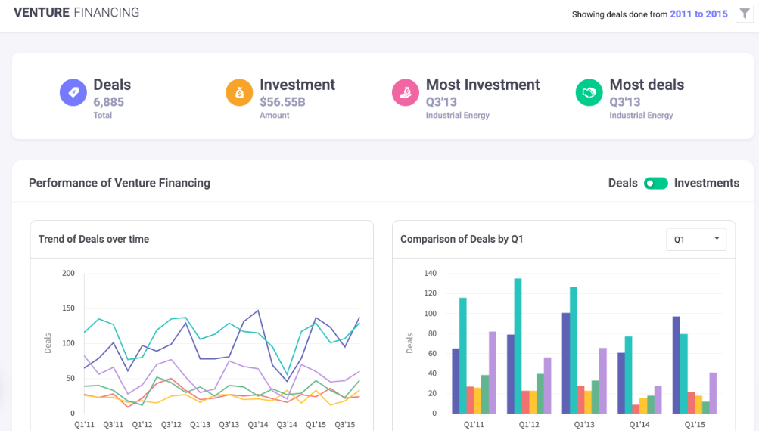

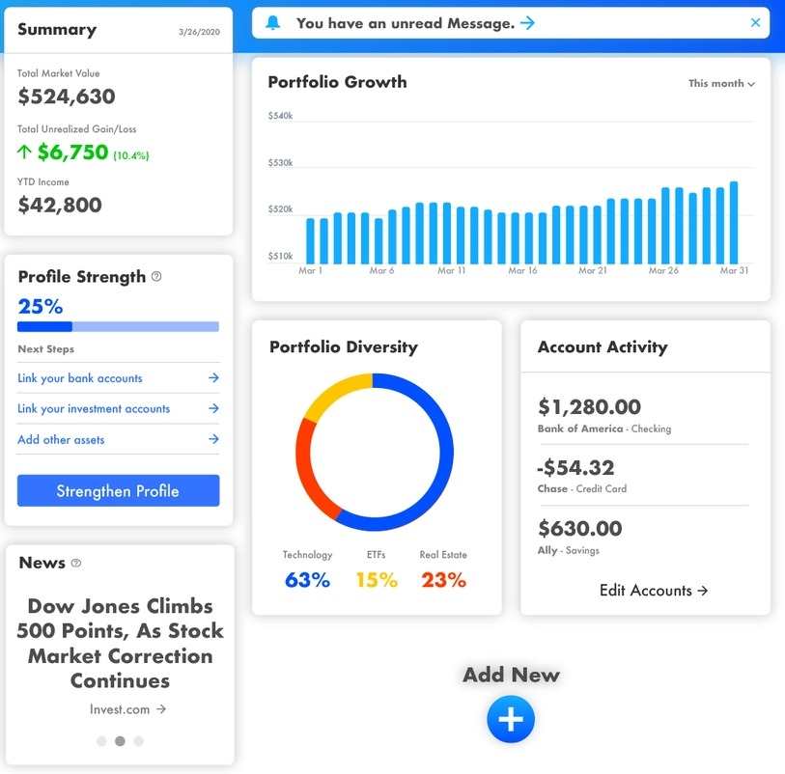

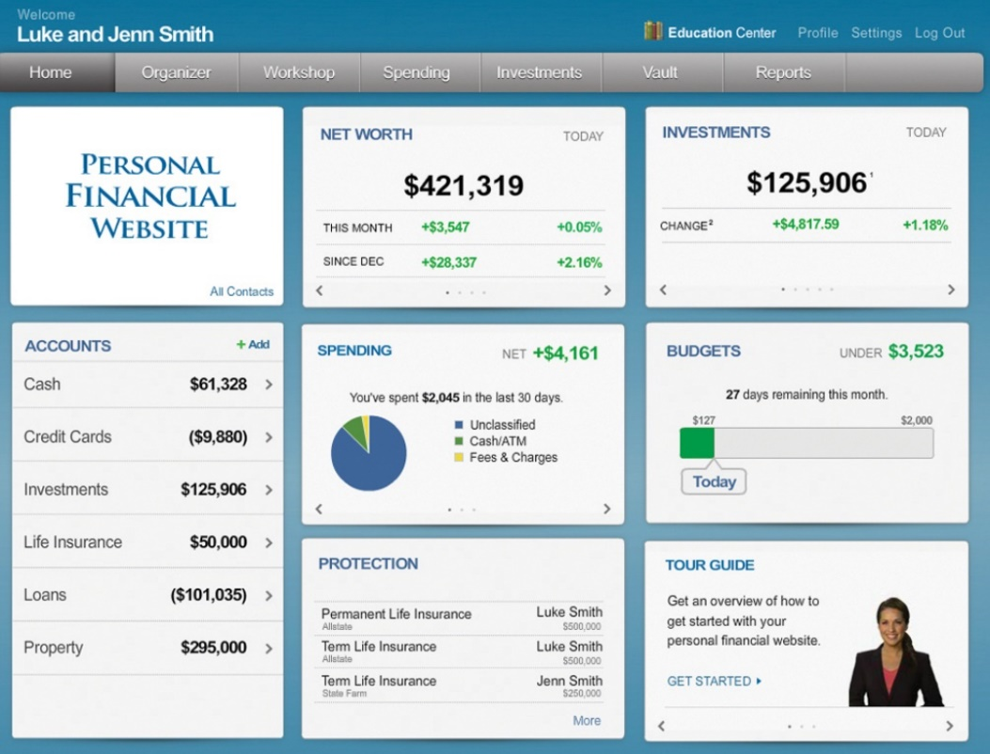

Video link for a sample app:

<https://www.personalcapital.com/financial-software>

Link to screens of sample app:

<https://seic.com/solutions/personal-wealth-management-high-net-worth-families/measure-what-matters/private-wealth-management-dashboard>